- Characteristics of Lasers,
- Stimulated Emission,
- Population Inversion,
- Einstein’s Coefficients,
- CO2 Laser,
- Semiconductor Laser,
- working of Laser Induced Breakdown Spectroscopy (LIBS) Instrument,
- Engineering Applications of Lasers.

Introduction:
LASER is an acronym for Light Amplification by Stimulated Emission of Radiation. Laser device produces a beam of coherent, monochromatic, intense and directional light. Hence laser light is highly organized when compared with the ordinary light. This is because the waves of a laser beam move in phase with each other travel in a narrow path in one direction. In the case of an ordinary light it spreads out, travels in different directions and hence it is incoherent. On account of the special properties, lasers are the most versatile and exploited tools in different fields such as Engineering, Medicine, Defence, Entertainment, Communication etc., Other common applications of laser include reading the bar code, cutting and welding metals, displays in light shows, playing music, printing documents, guiding missile to its target and so on.

Characteristics of Laser beam
  - Directionality:The design of the resonant cavity, especially the orientation of the mirrors to the cavity axis ensures that laser output is limited to only a specific direction. Since laser emits photons in a particular direction, the divergence is less when compared the other ordinary sources.
  - Monochromaticity:The laser beam is characterized by a high degree of mono-chromaticity (single wavelength or frequency) than any other conventional monochromatic sources of light. Ordinary light spreads over a wide range of frequencies, whereas laser contains only one frequency. The spectral bandwidth is comparatively very less when compared to ordinary light. Hence the degree of mono chromaticity is very high in lasers.
  - Coherence: The degree of coherence of a laser beam is very high than the other sources. The light from laser source consists of wave trains that are in identical in phase. Laser radiation has high degree of special (with respect to Space) and temporal (with respective to time) coherence.
  - High Intensity: The laser beam is highly intense. Since wave trains are added in phase and hence amplitudes are added. Laser light emits as a narrow beam and its energy is concentrated in a small region. Since all the energy is concentrated in the particular focus point, it is highly intense and bright. When laser beam is focused on a surface, the energy incident is of the order of millions of joules.
  - Focus ability: Since laser is highly monochromatic, it can be focused very well by a lens. It is so sharp the diameter of the spot will be close to the wavelength of the focused light. It can be focused to a very small area 0.7μm². Since even laser is not ideally monochromatic the spot diameter in actual cases will be 100 to 150 times larger than the wavelength.

Basic principles: Interaction of Radiation with Matter
Production of laser light is a consequence of interaction of radiation with matter under appropriate conditions. The interaction of radiation with matter leads to transition of the quantum system such as an atom or a molecule of the matter from one quantum energy state to another quantum state.
A material medium is composed of identical atoms or molecules each of which is characterized by a set of discrete allowed energy levels. An atom can move from one energy state to another when it receives or releases an amount of energy equal to the energy difference between those two states, which is termed as a quantum jump or transition.
Consider a two energy level system with energies E₁ and E₂ of an atom. E₁ is the energy of lower energy state and E₂ is the energy of excited state. The energy levels E₁ and E₂ are identical to all the atoms in the medium. The radiation (either absorbed or emitted) may be viewed as a stream of photons of energy (E₂-E₁)=hν, interacting with the material. These interactions lead to any one of the following
- Induced Absorption of radiation
- Spontaneous emission of radiation
- Stimulated emission of radiation

Induced Absorption:
Excitation of atoms by the absorption of photons is called induced absorption.
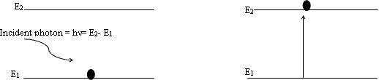
An atom in the lower energy state E₁absorbs the incident photon of energy (E₁-E₂) and goes to the excited state E_{2.} This transition is known as absorption. For each transition made by an atom one photon disappears from the incident beam.
for an atom A,
A + hν A*(excited state)
The number of absorption transitions per second per unit volume occurring in the material at any instant of time will be proportional to
- The Number of atoms in the ground state N₁
- Energy density of the incident radiation (ρ(ν))
Rate of induced absorption = B₁₂ρ(ν)N₁
where B₁₂ is proportionality constant which gives the probability of absorptions and it is called Einstein co-efficient of absorption. Since the number of atoms in the lower energy state is greater, the material absorbs more number of the incident photons.

Spontaneous Emission:
An atom which is at higher energy state E₂ is unstable, spontaneously returns to the lower energy state E₁ on its own during which a single photon of energy (E₂-E₁) = hυ is emitted, the process is known as spontaneous emission.
This spontaneous transition can be expressed as
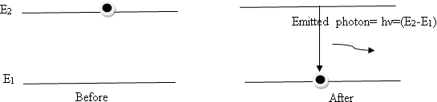
A * A +hυ

The number of spontaneous transitions per second, per unit volume depends on the number of atoms N₂ in the excited state.
Therefore, the rate of spontaneous emission = A₂₁N₂
Where A₂₁ is proportionality constant which gives the probability of spontaneous emission and it is called Einstein co- efficient of spontaneous emission of radiation.
The process has no control from outside. The instant of transition, directions of emission of photons, phases of the photons and their polarization states are random quantities. There will not be any correlation among the parameters of the innumerable photons emitted spontaneously by the assembly of atoms in the medium. Therefore the light generated by the source will be incoherent (ex: light emitted from conventional sources).

Stimulated Emission:
Emission of photons by an atomic system with an external influence is called stimulated emission. A mechanism of forced emission was first predicted by Einstein in 1916 in which an atom in the excited state need not wait for the spontaneous emission to take place. A photon of energy hυ = (E₂-E₁), can induce the excited atom to make downward transition and emit light. Thus, the interaction of a photon with an excited atom triggers it to drop down to the ground state (lower energy) by emitting a photon. The process is known as induced or stimulated emission of radiation.
A* + hυ A + 2 hυ
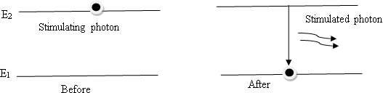

The number of stimulated transitions per second per unit volume in the material is proportional to
- The Number of atoms in the excited state N₂
- Energy density of the incident radiation (ρ(ν))
Rate of stimulated emission= B₂₁ ρ(ν)N₂
Where B₂₁ is proportionality constant which gives the probability of stimulated emissions and it is called Einstein co-efficient of induced (stimulated) emission.
The process of stimulated emission has the following properties.
- The emitted photon is identical to the incident photon in all respects. (It has the same frequency; it will be in phase and will travel in the same direction and will be in the same state of polarization).
- The process can be controlled externally.
- Stimulated emission is responsible for laser.

Some basic definitions
  - Atomic system : It is a system of atoms or molecules having discrete energy levels.
  - Active medium: It is the material medium composed of atoms or ions or molecules supports the basic interaction of radiation with matter in thermal equilibrium condition.
  - Energy density: The energy density ρ(ν) refers to the total energy in the radiation field per unit volume per unit frequency due to photons. It is given by the Plank’s distribution law
  - Population: It is the number density (the number of atoms per unit volume) of atoms in a given energy state.
  - Population Inversion and Meta stable state:
In order to increase stimulated emission it is essential that N₂>N₁ i.e., the number of atoms in the excited state must be greater than the number of atoms in the ground state. Even if the population is more in the excited state, there will be a competition between stimulated and spontaneous emission. The possibility of spontaneous emission can be reduced by using intermediate state where the life time of atom will be little longer (10⁻⁶ to 10⁻³s ) compared to excited state (10⁻⁹ s). This intermediate state is called metastable state and it depends upon the nature of atomic species used in the active medium.

6. Active medium:
It is the material medium composed of atoms or ions or molecules in which the laser action is made to take place, which can be a solid or liquid or even a gas. In this, only a few atoms of the medium (of particular species) are responsible for stimulated emission. They are called active centers and the remaining medium simply supports the active centers.

7. Pumping Mechanism:
To achieve the population inversion in the active medium, the atoms are to be raised to the excited state. It requires energy to be supplied to the system. The process of supplying energy to the medium with a view to transfer the atoms to higher energy state is called pumping.

Expression for energy density of incident radiation in terms of Einstein coefficients:

Consider an atomic system interacting with radiation field of energy density U_{γ}. Let E₁ and E₂ be two energy states of atomic system (E₂> E₁). Let us consider atoms are to be in thermal equilibrium with radiation field, which means that the energy density U_{γ} is constant in spite of the interaction that is taking place between itself and the incident radiation. This is possible only if the number of photons absorbed by the system per second is equal to the number of photons it emits per second by both the stimulated and spontaneous emission processes.
We know that,
The rate of induced absorption = B₁₂ ρ(ν)N_{1,} T
The rate of spontaneous emission = A₂₁N₂ T
The rate of stimulated emission = B₂₁ ρ(ν)N₂
N₁ and N₂ are the number of atoms in the energy state E₁ and E₂ respectively, B₁₂, A₂₁ and B₂₁ are the Einstein coefficients for induced absorption, spontaneous emission and stimulated emission respectively.

At thermal equilibrium,
Rate of induced absorption = Rate of spontaneous emission + Rate of stimulated emission
B12N1 ρ(ν) = A21N2 + B21N2 ρ(ν) or
ρ(ν) (B₁₂N₁ – B₂₁N₂) = A₂₁N₂
ρ(ν)= $\frac{ A21N2}{(B12N1 – B21N2) }$
By rearranging the above equation, we get
ρ(ν)= $\frac{ A21N2}{B21N2 (\frac{B12N1}{B21N2} – 1) }$
ρ(ν)= $\frac{ A21/B21}{\frac{B12 N1}{B21 N2} – 1 }$
In a state of thermal equilibrium, the populations of energy levels E₂ and E₁ are fixed by the Boltzmann factor given by
N1 = No$exp\frac{-E1}{KT}$
N2 = No $exp\frac{-E2}{KT}$
Then,$\frac{N1}{N2}$ = $\frac{No exp\frac{-E1}{KT}}{No exp\frac{-E2}{KT}}$
$\frac{N1}{N2}$ = exp ($\frac{E2-E1}{KT}$)
$\frac{N1}{N2}$ = exp ($\frac{hν}{KT}$)
Substitute the value in Energy density equation
ρ(ν)= $\frac{ A21/B21}{\frac{B12 }{B21 } exp⁡(\frac{hν}{KT}) – 1 }$
We know that Plancks radiation law ρ(ν)= $\frac{\frac{8πhν3}{c3}}{1 expexp \left(\frac{hν}{KT}\right) – 1}$
Comparing both equations We get,
$\frac{A21}{B21}$ = $\frac{8πhν3}{c3}$ and $\frac{B12 }{B21 }=1$ === > B₁₂= B₂₁ = B
This implies that the probability of induced absorption is equal to the probability of stimulated emission. Due to this identity the subscripts could be dropped, and A₂₁ and B₂₁ can be simply represented as A and B
.

Carbon dioxide LASER(CO₂ LASER) : Construction & working Principle of Carbon dioxide laser
Carbon dioxide laser developed by Indian born American scientist Prof.C.K.N.Patel (Chandra Kumar Naranbhai Patel) at AT & T Bell laboratories, USA in the year 1963. It is a four- level laser, operates at 10.6 μm in the far IR region. It has a very high efficiency and is widely used for industrial drilling, cutting and welding. It is also used in medical surgery especially in cosmetic aspects. CO₂ laser is a molecular gas laser in which laser action is achieved by transitions between vibrational and rotational levels of molecules. Its construction is simple and the output of this laser is continuous. In the CO2 molecular gas laser, transition takes place between the vibrational states of Carbon dioxide molecules.

Vibrational energy levels of carbon dioxide molecule
Carbon dioxide molecule has three different modes of vibration shown below. The energies of associated with each of these vibrations are quantized in different sets.

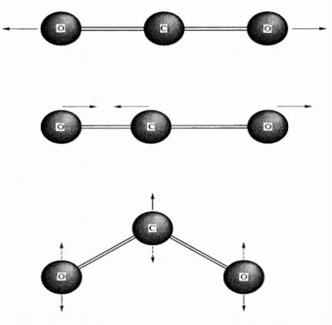
A

B

C

Symmetric stretching (a): In this mode, carbon atom remains stationery when the oxygen atoms oscillate simultaneously along the molecular.
Asymmetric stretching (b): Here the two oxygen atoms move in one direction while the carbon atom moves in the opposite direction and vice versa. In this stretching mode the molecule possesses highest energy and this state is represented as E5 state.
Bending mode (c): In bending mode, all the three atoms oscillate normal to the molecular axis. While vibrating, the two oxygen atoms pull together in one direction as the carbon atom is displaced in the opposite direction

Construction of CO₂ laser:
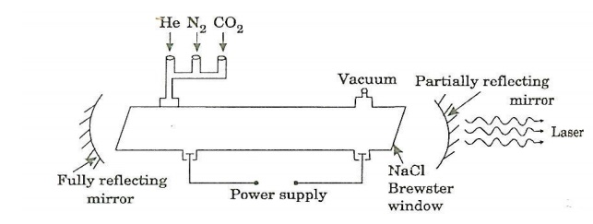
CO₂ laser consists of a quartz tube 5 m long and 2.5 cm in the diameter. This discharge tube is filled with gaseous mixture of CO2(active medium), Nitrogen (N₂) and Helium (H₂)gasses in the ratio of 1:2:3 with suitable partial pressures. Sometimes traces of Hydrogen or water vapour are added. The pressure inside the tube is 6 -17 torr.

The terminals of the discharge tubes are connected to a D.C power supply. The ends of the discharge tube are fitted with NaCl Brewster windows so that the laser light generated will be polarized. The optically plane mirrors are fixed on either side of the tube normal to its axis as shown in the figure. One of the mirrors is fully silvered and can reflect the entire incident light whereas the other one is partially silvered to get polarized laser beam output.

Working:
When a suitable voltage is applied across the two electrodes, a glow discharge of the gasses is initiated in the tube. During discharge the free electron from gas are accelerated towards positive electrode. These free electrons collide with the N₂ molecules and hence N₂ molecules are raised to the first vibrational level which is meta stable state designated as ν=1(excited) as shown in energy level diagram. This type of collision is called collision of first kind and can be written as
e₁ + N₂ = e₂ + N₂*
where e₁ and e₂ are electrons with different energies before and after collision respectively and N₂ and N₂* are the nitrogen molecules in the ground and ν=1 state respectively.
Since ν=1state is the metastable state of N₂, the molecules remain there for a relatively long time which leads to an increase of population in ν=1(excited) state. The vibrational energy level corresponding to the metastable state of N₂ (ν=1) is close coincidence with E5 energy state of CO₂. Because of matching of energy levels, there is a resonance transfer of energy takes place from the N₂ molecule to a CO₂ molecule through collisions. As a result, a greater number of CO₂ molecules get elevated to E5 state and N₂ molecule returns to the ground state. This type of collisions belongs to the class of collision of second kind and represented as

N₂* + CO₂ = N₂ + CO₂*.
Where CO₂ and CO₂* refer to the carbon dioxide molecule in the ground and excited state respectively.N₂*and N₂ are nitrogen molecules in excited and ground states respectively.

Energy level diagram of CO₂ laser
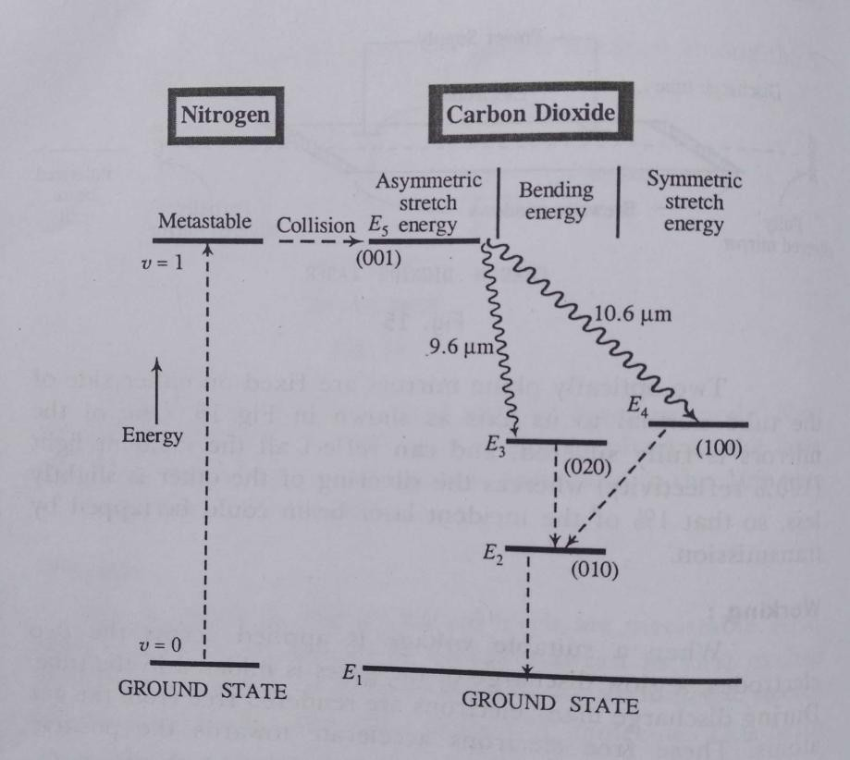
Due to the resonance transfer, the state E₅ is heavily populated and achieves population inversion with respect to E₃ and E₄. Photons are emitted spontaneously by a few of the atoms at the energy level E₅, these spontaneous photons travelling through the gas mixture triggers lasing between E₅& E₃ and E₅& E₄ energy levels.
- The transition from E₅ level to the E₄ level gives rise to radiation of wavelength 10.6 μm which is in the far infrared region.
- The transition from E₅ level to E₃ level gives rise to radiation of wavelength 9.6 μm which is also in the far infrared region.
Further transitions, The CO₂ molecules in the E₃ level come down to E₂ level during collision with those in the E₂ level by giving up energy. The collision of molecules in the E₂ level with He and water vapor leads to a quick E₂ to E₁ transition favoring the depopulation of E₃ and E₄ levels and population inversion of E₅ with E₃ and E₄ levels.
The IR photons released parallel to the axis of the tube are reflected back and the multiplication of stimulated emission takes place. The multiple reflections of the photons between the mirrors intensify the laser beam and it emerges through the partially reflecting mirror.
The laser beam consists of two components i.e 10.6µm and 9.6µm. One of the components of the beam can be eliminated by placing a prism between the Brewster window and the partially reflecting mirror.

Semiconductor LASER or Diode LASER:
Semiconductor diode LASER is an LED with heavily doped P and N sections. First semiconductor LASER was fabricated in 1962 using 𝐺𝑎𝐴𝑠. It is a low cost and high efficiency LASER.
Principle: Semiconductor diode laser emits highly coherent laser beam when a p-n junction of the diode is forward biased. A photon is emitted by spontaneously during recombination process induce more number of stimulated emission which produces laser.
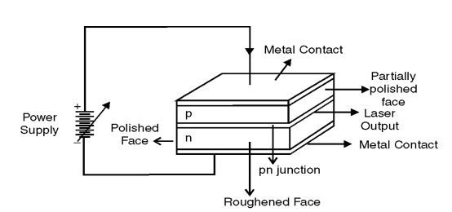
Construction: Figure shows the basic construction of 𝐺a𝐴𝑠 semiconductor laser. GaAs is a highly doped p-n junction. Active medium is a p-n junction made from the single crystal of GaAs. This crystal is cut in the form of a thin layer of about 0.5mm. The two faces are perpendicular to p-n junction are polished and silvered. They act as optical resonator and laser beam finally comes out from partially silvered face as shown in the figure. The other two faces parallel to p-n junction are fused with metal contacts across which forward voltage is applied using power supply.
Working: Figure shows the energy level diagram of semiconductor laser. The energy band consists of valence band Ev and conduction band Ec separated by energy gap, where conduction band contains electrons and valence band contains holes. For semiconductor laser, heavily doped p-type and n-types are fused to form p-n junction. The Fermi level is pushed into VB (p-type) and CB (n-type) to attain equilibrium as shown in figure.
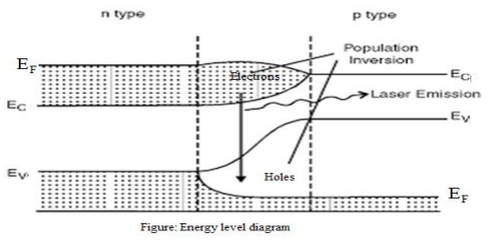
Fig: Energy level diagram of Semiconductor LASER diode
When forward voltage is applied across the junction, electrons from n-type enter into p-region where they recombine with holes causing spontaneous emission. This could be considered as the transition of electron from conduction band to valance band. The concentration of electron and hole is relatively less. Now if the forward current is sufficiently high, more number of electrons is injected into the p-region and carrier concentration in the active region increases to high value. Hence population inversion can be achieved. The photons emitted initially due to spontaneous emissions which in induce further stimulated emissions. The LASER cavity helps in the amplification of light and finally LASER beam is comes out from partially silvered face.The wavelength of the LASER emitted can be calculated by using the relation,
𝜆 = ℎc /𝐸_{g} (Where E_{g} is the energy band gap of semiconductor.)

i. Type: Solid state semiconductor laser.
ii. Active medium: A pn junction diode made from a single crystal of gallium arsenide.
iii. Pumping method: Direct conversion method.
iv. Power output: a few mW.si
v. Nature of output: Continuous wave or pulsed output.
vi. Wavelength of output: 8300 Å to 8500 Å.

S.No | Homojunction laser | Heterojunction laser
1 | It is made by a single crystalline material | It is made by different crystalline materials
2 | Power output is low | Power output is high
3 | It has high threshold current density | It has low threshold current density
4 | Life time & Cost is less | Life time &Cost is more
5 | Eg: GaAs, InP | Eg: GaAs/GaAlAs, InP/InAl

- Laser-Induced Breakdown Spectroscopy (LIBS)
Laser-Induced Breakdown Spectroscopy (LIBS) is a type of atomic emission spectroscopy that utilizes a high-energy laser pulse to ablate a small amount of material from the surface of a sample, creating plasma. The light emitted from the plasma contains characteristic wavelengths that correspond to the elements present in the sample. By analyzing the emitted light, the elemental composition of the material can be determined.
Construction
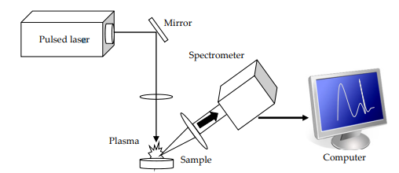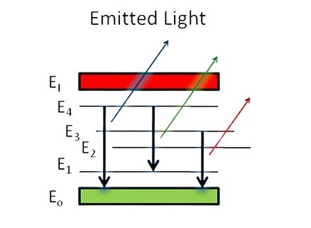
The basic components of a LIBS system include:
- Laser Source: A high-energy pulsed laser (usually a Nd-YAG Pulsed laser of wavelength 1064nm, 532nm and 355nm) that emits short, intense pulses of light. The laser is typically operated in the nanosecond or femtosecond range to produce sufficient energy for plasma formation.
- Optical Delivery System: A set of lenses and mirrors used to focus the laser beam onto the sample surface. This system ensures that the laser beam is accurately directed and focused to a small spot size, providing the necessary energy density for plasma formation.
- Sample Stage: A holder or platform where the sample is placed. The stage can be stationary or movable to allow for scanning across different areas of the sample.
- Spectrometer: An instrument that disperses the light emitted from the plasma into its component wavelengths. This is usually done using a diffraction grating, and the dispersed light is then directed onto a detector.
- Detector: A device (commonly a CCD (charge-coupled device), camera or photodiode array) that captures the dispersed light and converts it into an electronic signal. The detector records the intensity of the emitted light at different wavelengths.
- Computer and Software: A computer system with software to control the laser, spectrometer, and detector, and to analyze the spectral data to identify and quantify the elements present in the sample.
Working Principle
The working of LIBS can be summarized in the following steps:
- Laser Focusing and Ablation: The laser source emits a high-energy pulse that is focused onto the surface of the sample. The main physical process that forms the essence of LIBS technology is the formation of high-temperature plasma, induced by a short laser pulse. When the short-pulse laser beam is focused onto the sample surface, a small volume of the sample mass is ablated (i.e. removed via both thermal and non-thermal mechanisms) — in a process known as Laser Ablation.
- Plasma Formation: This ablated mass further interacts with a trailing portion of the laser pulse to form highly energetic plasma that contains free electrons, excited atoms and ions.
- Emission of Light: When the laser pulse terminates, the plasma starts to cool. During the plasma cooling process, the electrons of the atoms and ions at the excited electronic states fall down into natural ground states, causing the plasma to emit light with discrete spectral peaks.
- Spectral Analysis: The emitted photons from the plasma are collected through a lens near the plasma and transmitted to the spectrometer via fiber optic, where it is dispersed into its component wavelengths. The detector captures the spectral lines and records the intensity of light at each wavelength.
- Data Interpretation: The computer software analyzes the spectral data to identify the elements present based on the characteristic wavelengths of the emitted light. Each element in the periodic table is associated with unique LIBS spectral peaks. By identifying different peaks for the analyzed samples, its chemical composition can be rapidly determined. Often, information on LIBS peak intensities can be used to quantify the concentration of trace and major elements in the sample.
Applications of LIBS
- Elemental Analysis: LIBS is widely used for rapid and sensitive elemental analysis of solids, liquids, and gases.
- Environmental Monitoring: It is used for detecting pollutants and contaminants in air, water, and soil.
- Industrial Quality Control: LIBS is used for material identification and sorting in industries such as metallurgy, recycling, and mining.
- Cultural Heritage: It helps in the non-destructive analysis of historical artifacts and artworks to determine their composition.
8. Engineering Applications of LASER
1. The laser beam is highly energetic; hence it is used to destroy huge objects like aircrafts, missiles, etc., in few seconds by directing the laser beam on the objects. Hence it is also called as death ray of war weapon.
2. The laser gun is high convergent, hence focusing a spot at a short range vapourise the governing part of the object
3. Laser beam can exactly determine the size, form, distant, velocity and direction of any distant object (missile, war plane, etc.,) by receiving the reflected laser beam on a cathode screen as in RADARs. 4. It is used for automatically guiding rocket and satellite
5. It is used for forecasting earthquakes
6. Lasers are used for spectroscopy applications, LIBS

